**SIR Model Simulation Analysis for Bucharest**

Introduction: Hello! I'm Jarin Akter Sumiya, a student at the Romanian American University. This document details my project for the Numerical Methods course, taught by Professor Andrei Luchici. In this project, I have applied the SIR (Susceptible, Infected, Recovered) model to simulate the spread of an infectious disease in Bucharest.

Understanding the SIR Model: The SIR model is a mathematical approach used in epidemiology to predict how diseases spread in a population. It categorizes people into three groups:

Susceptible (S): Individuals who are not yet infected but are vulnerable to the disease.

Infected (I): Individuals who have the disease and can transmit it to others.

Recovered (R): Individuals who have recovered from the disease and are no longer infectious.

This model is key to understanding the dynamics of disease transmission in a community.

Why Bucharest? I chose Bucharest, the vibrant capital of Romania, for my simulation. With its significant population of approximately 1.8 million, it presents an interesting case for studying the impact of an infectious disease on a large urban area.

# Methodology of the Simulation:

## Tools and Setup:

* I used Python programming language and libraries such as numpy, scipy, and matplotlib for numerical calculations and visualizations.
* The total population was set to 1.8 million, with 1,000 individuals initially infected.

## Implementing the Model:

* The SIR model equations were used to simulate the disease's progression over time.

Graphical Representation of the Simulation: The accompanying graph illustrates the SIR model's simulation results over a 160-day period. The blue curve represents the susceptible population, the yellow curve represents the infected population, and the green curve represents the recovered population.

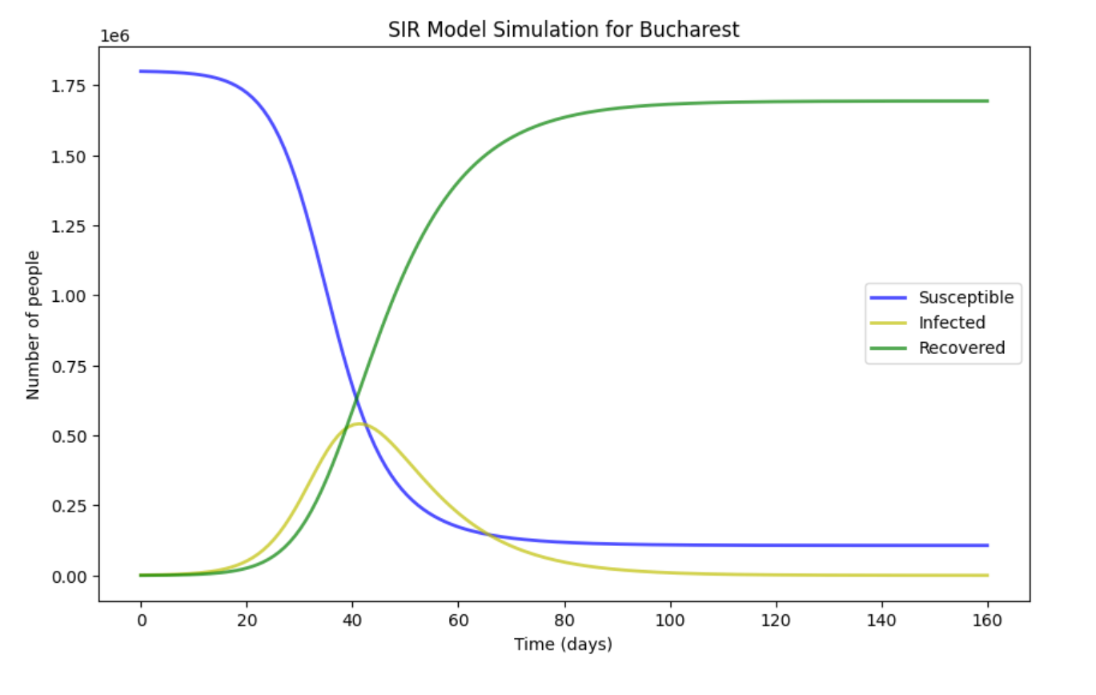

Analysis and Observations: The simulation starts with the entire population being susceptible, except for 1,000 individuals who are initially infected. As the simulation progresses, we observe the following trends:

Rapid Increase in Infected Population: The yellow curve rises sharply in the initial phase, indicating a rapid increase in infection as the disease spreads through contact with susceptible individuals.

Peak Infection: The infected population reaches a peak relatively quickly, suggesting a high transmission rate. This peak represents the point at which the spread of the disease is at its most intense.

Decline in Susceptible Population: Correspondingly, the blue curve, which represents the susceptible population, shows a steep decline as more individuals become infected.

Recovery and Plateau: After the peak, the number of infected individuals begins to decline as more and more people recover from the disease (green curve). This is due to the depletion of susceptible individuals and the increase in recovered individuals who are now immune.

Stabilization: Eventually, the system stabilizes, and all three curves plateau, indicating the end of the disease's active spread. The susceptible and infected populations decrease to low levels, while the recovered population remains high.

These trends are consistent with what we would expect from the SIR model in a closed population where no new individuals are introduced, and there is no loss of immunity over time.

Implications: The simulation suggests that without intervention, the disease could spread rapidly through the population, infecting a significant portion before herd immunity contributes to a reduction in new infections. This underscores the importance of early intervention and public health measures such as social distancing, vaccination, and quarantine to control the spread of the disease.

Conclusion: This project has been an enlightening experience in applying numerical methods to a practical and globally relevant issue. It has enhanced my understanding of how mathematical models like the SIR can be crucial tools in analyzing and predicting the spread of infectious diseases in populous cities like Bucharest.

Acknowledgements: I would like to express my gratitude to Professor Andrei Luchici for his invaluable guidance and to my peers at the Romanian American University for their support throughout this project.